**Task # 01: Create Birthday Card Application.**

**XML FILE:**

*<?***xml version="1.0" encoding="utf-8"***?>*<**RelativeLayout xmlns:android="http://schemas.android.com/apk/res/android"  
 xmlns:app="http://schemas.android.com/apk/res-auto"  
 xmlns:tools="http://schemas.android.com/tools"  
 android:layout_width="match_parent"  
 android:layout_height="match_parent"  
  
 android:visibility="visible"  
 tools:context=".MainActivity"**>  
  
 <**ImageView  
 android:id="@+id/imageView4"  
 android:layout_width="match_parent"  
 android:layout_height="match_parent"  
 android:background="@drawable/download"  
 android:scaleType="centerCrop"** />  
  
 <**TextView  
 android:id="@+id/textView"  
 android:layout_width="wrap_content"  
 android:layout_height="wrap_content"  
 android:layout_alignParentRight="true"  
 android:layout_alignParentBottom="true"  
 android:fontFamily="sans-serif-light"  
 android:padding="20dp"  
 android:text="From, Aneela!"  
 android:textColor="#800080"  
 android:textSize="36sp"** />  
  
  
 <**TextView  
 android:layout_width="wrap_content"  
 android:layout_height="wrap_content"  
 android:fontFamily="sans-serif-light"  
 android:padding="20dp"  
 android:text="To, Summaya!"  
 android:textColor="#800080"  
 android:textSize="36sp"  
 android:visibility="visible"** />  
  
  
</**RelativeLayout**>

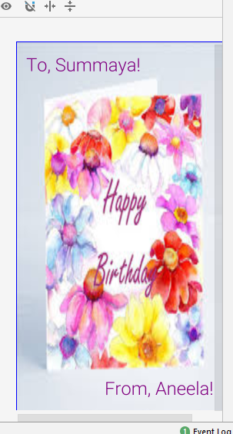

**Task # 02: Create Login Page.**

**XML FILE:**

<?xml version="1.0" encoding="utf-8"?>

<RelativeLayout xmlns:android="http://schemas.android.com/apk/res/android"

xmlns:app="http://schemas.android.com/apk/res-auto"

xmlns:tools="http://schemas.android.com/tools"

android:layout_width="match_parent"

android:layout_height="match_parent"

tools:context=".MainActivity">

<TextView

android:id="@+id/text1"

android:layout_width="wrap_content"

android:layout_height="wrap_content"

android:layout_centerHorizontal="true"

android:layout_centerInParent="false"

android:text="SIGN IN"

android:layout_marginTop="14dp"

android:textAppearance="?android:attr/textAppearanceLarge"

/>

<TextView

android:id="@+id/textuname"

android:layout_width="wrap_content"

android:layout_height="wrap_content"

android:layout_below="@+id/text1"

android:layout_marginTop="20dp"

android:text="Username "

android:textAppearance="?android:attr/textAppearanceLarge" />

<EditText

android:id="@+id/editTextuname"

android:layout_width="wrap_content"

android:layout_height="wrap_content"

android:layout_alignParentRight="true"

android:layout_alignTop="@id/textuname"

android:layout_toRightOf="@id/textuname"

/>

<TextView

android:id="@+id/textpass"

android:layout_width="wrap_content"

android:layout_height="wrap_content"

android:layout_below="@id/textuname"

android:layout_marginTop="20dp"

android:text="Password "

android:textAppearance="?android:attr/textAppearanceLarge" />

<EditText

android:id="@+id/editTextpass"

android:layout_width="wrap_content"

android:layout_height="wrap_content"

android:layout_alignParentRight="true"

android:layout_alignTop="@+id/textpass"

android:layout_toRightOf="@+id/textpass"

android:inputType="textPassword"

/>

<Button

android:id="@+id/btnSubmit"

android:layout_width="wrap_content"

android:layout_height="wrap_content"

android:layout_alignParentLeft="false"

android:layout_below="@+id/editTextpass"

android:layout_centerInParent="true"

android:text="LOGIN" />

</RelativeLayout>

